**Ain Shams University**  
**Faculty of Computer & Information Sciences**

**Computer Science Department**

Fantasy Premier League Points Prediction

[ITIDA Logo if exists]

**July 2022**

[Sponsor Logo if exists]

**Ain Shams University**  
**Faculty of Computer & Information Sciences**

**Computer Science Department**

**By:**

Yousef Ali Antar [General]

Yousef Ayman Essam [General]

Yousef Essam Ibrahim [General]

Yahia Mohamed Sedki [General]

Yahia Mohamed Othman [General]

Fantasy Premier League Points Prediction

**Under Supervision of :**

[Supervisor 1]

[Supervisor Title],

Computer Science Department,

Faculty of Computer and Information Sciences,

Ain Shams University.

[Supervisor 2]

[Supervisor Title],

Computer Science Department,

Faculty of Computer and Information Sciences,

Ain Shams University.

# Acknowledgement

If you want to include thank you notes to any one you should put it here. (The acknowledgement is optional)

# Abstract

The abstract is a one page summary of the whole project including: why the project is needed, what are the main features of the project and what are the final results obtained by the developed system.

It’s the most important page in the whole documentation, it should be the last thing you write.

**Table of Contents**

Acknowledgement i

Abstract ii

List of Figures iv

List of Abbreviations v

1- Introduction 1

1.1 Motivation 1

1.2 Problem Definition 1

1.3 Objective 1

1.4 Time Plan 1

1.5 Document Organization 1

2- Background 2

3- Analysis and Design 3

3.1 System Overview 3

3.1.1 System Architecture 3

3.1.2 System Users 3

3.2 System Analysis & Design 3

3.2.1 Use Case Diagram 3

3.2.2 Class Diagram 3

3.2.3 Sequence Diagram 3

3.2.4 Database Diagram 4

4- Implementation and Testing 5

5- User Manual 6

6- Conclusion and Future Work 7

6.1 Conclusion 7

6.2 Future Work 7

References 8

# List of Figures

**Figure 1- Neural Network general architecture** 4

Note: Always number your figures and include a caption under each one like this. Then if you update the list above it’ll be updated automatically.

When adding a figure, right click on the image -> insert caption.

After you finish the document, write click on the table and choose update field, then update entire table.

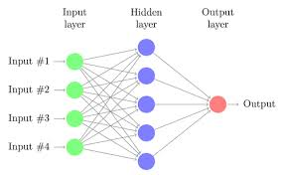

**Figure 1- Neural Network general architecture**

Add list of Tables if you have tables in your text

# List of Abbreviations

|  |  |  |
| --- | --- | --- |
| Abbreviation | What the abbreviation stands for |  |
| EPL | English Premiere League |  |
|  |  |  |
|  |  |  |
|  |  |  |
|  |  |  |

Note: Any abbreviations used throughout the document should be included here. The list should be sorted **alphabetically**.

# Introduction

## **1.1 Motivation**

Fantasy Premier League is a very popular game that is played by around 10 million people worldwide. It’s a game that casts you in the role of a Fantasy manager. You are given the task to pick a squad of real-life players who score points for your team based on their performances in their own real-life matches.

## **1.2 Problem Definition**

Fantasy Premier League players suffer a lot while picking their team.

The most common problems are:

* Picking wrong players
* Transferring out a player that scores many point the next Gameweek
* Dealing with injured players on your team
* Your bench players scores more points than the starters (as you don’t get points for bench player)
* Choosing wrong captain (your captain gives you double the points he scores)

## **1.3 Objective**

We are aiming to:

* Train a machine learning model to best produce the near ultimate equation of prediction in the sports field to do the following:
  1. Predict the points of the players accurately.
  2. Predict matches results.
  3. Predict if a player is going to miss a game to transfer the player out of the team.
  4. Predict the Man of The Match.
* To create a graphical user interface with the following features:
  1. Allowing clients to have their own accounts.
  2. Being a modern, user-friendly interface.
  3. Automatically build a random team based on the prediction scales
  4. Send a review of the statistics of each week with what (predicted or unexpected) events occurred.
* Summarization: To build the best possible team and becoming the top of the rankings in the game.

## **1.4 Time Plan**

|  |  |  |
| --- | --- | --- |
| **Project Activities** | **Start Date** | **End Date** |
| Survey | November 2021 | November 2021 |
| *…* Requirement Specifications  Project Analysis  Use cases  ER Diagrams  Sequence Diagram  . . .  Project Design  Project Architecture  User Interface Design  . . .  Project Testing  Modules Testing  Modules Integration  . . .  Team Work  Weekly Team Member/Tasks table  Requirement Specifications | December 2021 | December 2021 |
| Project Analysis  Use cases  ER Diagrams  Sequence Diagram | January 2022 | February2022 |
| Project Design  Project Architecture  User Interface Design | February 2022 | April 2022 |
| Project Testing  Modules Testing  Modules Integration | April 2022 | May 2022 |
| Project Documentation | May 2022 | June 2022 |

## **1.5 Document Organization**

Include a paragraph for each chapter describing what was discussed in this chapter starting with chapter 2.

# Background

// A detailed description of the field of the project.

Sports analytics is the practice of applying mathematical and statistical principles to sports and related peripheral activities. While there are many factors and priorities specific to the industry, sports analysts use the same basic methods and approach as any other kind of data analyst.

// All the scientific background related to the project.

//A survey of the work done in the field.

Most of our audience pick players with good fixtures or in good form. 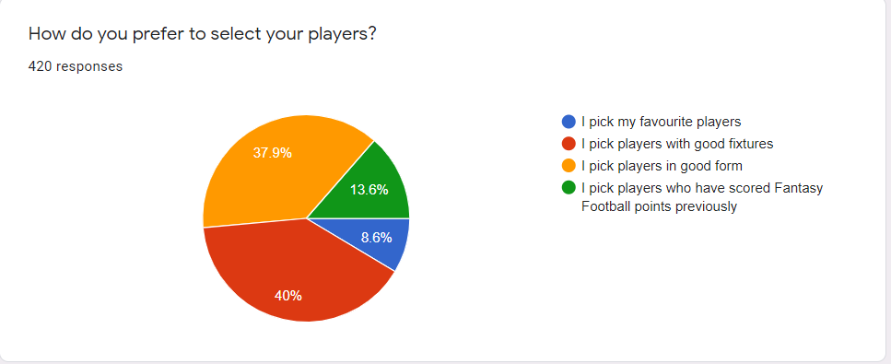

Most of our audience look at their Team at least a few times a week.

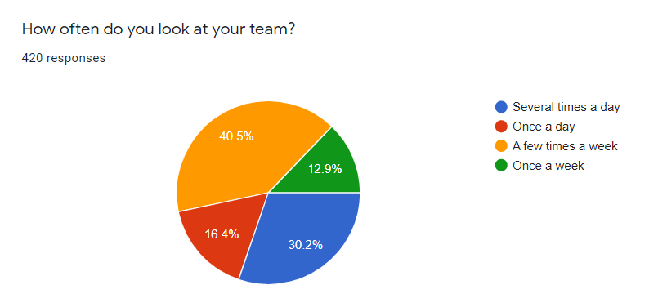

Most of our audience discuss Fantasy Football with their friends.

Most of our audience are interested in using the app.

//Description of existing similar systems.

1. **Machine Learning Outperforms Logistic Regression Analysis to Predict Next-Season NHL Player Injury / National Hockey League :-**
   * 1. Author name: *GU, W., Foster, K., Shang, J. and Wei, L.*
     2. Publish date: (2019).
     3. Techniques used in this system: Logistic Regression – Random Forrest – K nearest Neighbors - XGBoost Boosting Algorithm.
     4. Accuracy: 94.6%
     5. Dataset Used: NHL Stats, History, Scores, Records.
2. **NBA Game Result Prediction Using Feature Analysis and Machine Learning/National Basketball Association :-**
   * 1. Author name: *Fadi Thabtah, Li Zhang, Neda Abdelhamid.*
     2. Publish date: (2019).
     3. Techniques used in this system: Feature Selection Using Correlation Feature Set (CFS) and RIPPER Algorithm - Artificial Neural Networks (ANN), Naïve Bayes, Logistic Model Tree (LMT).
     4. Accuracy: 71-83%
     5. Dataset Used: NBA-Players-Stats (Kaggle).
3. **Predicting The Winner of NFL Games Using Machine and Deep Learning/National Football League :-**
   * 1. Author name: *Pablo Bosch.*
     2. Publish date: (2018).
     3. Techniques used in this system: Deep Learning Using Artificial Neural Network (ANN) - Recurrent Neural Network (RNN) Using Binary Cross Entropy - K-Fold Cross Validation.
     4. Accuracy: 63%
     5. Dataset Used: NFL-Game API, NFLDB

# Analysis and Design

## 3.1 System Overview

### 3.1.1 System Architecture

Include a figure of the system architecture and a description of all modules.

You may add Functional and non-functional requirements section –If needed–

### 3.1.2 System Users

1. *Intended Users:*

To whom the system is built, and how each group of users will use the system.

1. *User Characteristics*

What kind of experience or skills are required from the users to be able to operate the project effectively.

## 3.2 System Analysis & Design

### 3.2.1 Use Case Diagram

The use case diagram + fully dressed use cases describing each function of the project.

### 3.2.2 Class Diagram

The diagram + description of all the main classes.

### 3.2.3 Sequence Diagram

### 3.2.4 Database Diagram

If you are implementing a database include the database schema plus a description of the tables.

# Implementation and Testing

This chapter should include:

* A detailed description of all the functions in the system.
* A detailed description of all the techniques and algorithms implemented.
* Description of any new technologies used in implementation.
* UI Design and Wireframes
* Testing procedures and levels used

# User Manual

This chapter should describe in details how to operate the project along with screen shots of the project representing all steps.

This chapter should also include an "Installation Guide" that would describe how to install the program, and all required third party tools that needs to be available for the project to run. The installation guide will also be included as a readme file in the CDs delivered at the end of the year.

# Conclusion and Future Work

## 6.1 Conclusion

A complete summary of the whole project along with the results obtained.

## 6.2 Future Work

What can be done in the future to improve the performance of the project and what additional functions could be added?

Add Appendices if you think it’s needed like:

1. Main code segments
2. Any surveys made

# References

The list of references used during the project or in writing the document. The references should be formatted properly, you can refer to http://education.exeter.ac.uk/dll/studyskills/harvard_referencing.htm for details on how to format your reference list.

It’s preferable to use word references to make it easier.